**Jaypee University Anoopshahr**

A project report

On

**“FACE RECOGNIZATION ATTENDANCE SYSTEM”**

Submitted in partial fulfillment of the requirement for the award of the Degree of:

**B.Tech in Computer Science & Engineering**



Session Year:- 2020-2021

|  |  |
| --- | --- |
| **Submitted to:**  Dept. of computer Science & Engineering | **Submitted by:**  Vipul Goyal (881713034)  Sajal Bansal (8817103036)  Abhinav Joshi (8817103002) |

Done under the guidance of :

**Er. Lalit Mohan Gupta** Certificate

###### This is to certify that a Project Report on **“Face Recognization Attendance System”** Submitted by (**Abhinav Joshi, Sajal Bansal, Vipul Goyal)** to the Department of CSE, in the partial fulfillment of the requirement for the degree of Bachelor of Technology in Computer Science and Engineering by **Jaypee University Anoopshahr** (Est. Under U.P. Act No 8 of 2014) is a record of their work under my supervision and guidance.

**Er. Lalit Mohan Gupta Dr. Nishant Srivastav**

(Assistant Professor, CSE) (H.O.D, C.S.E)

Acknowledgement

The project “**Face Recognization Attendance System**” is outcome of guidance, moral support and devotion bestowed on us throughout our work. For this we acknowledge and express our profound sense of gratitude and thanks to everybody who have been a source of inspiration during the making of this project.

The constant guidance and encouragement received from our mentor, **Er. Lalit Mohan Gupta,** faculty of Computer Science Department, Jaypee University, Anoopshahr. He has been a great support in carrying out the project work and is acknowledged with reverential thanks.

Special thanks to the **Department of Computer Science and Engineering** (C.S.E.) of JAYPEE UNIVERSITY that provided great environment and valuable resources to us in this project. Not forgetting to thank our friends who are always ready to lend us helping hands.

Thank you for sharing a lot of good ideas to improve our work and bringing us unlimited joy.

INDEX

|  |  |  |
| --- | --- | --- |
| **S. No.** | **TITLE** | **Page No.** |
| **1** | Introduction | 5 |
| **2** | Problem Statement | 6 |
| **3** | Scope / Objective | 7 |
| **4** | Structure of a project | 8 |
| **5** | Data Flow Diagram | 9 |
| **6** | Use Case Diagram | 10 |
| **7** | Database Overview | 11 |
| **8** | Tool and technique used | 12 |
| **9** | Application feature overview | 13 |
| **10** | Codes | 14-25 |
| **11** | Output Screens | 26-37 |
| **12** | Limitations | 38 |
| **13** | Future Enhancement | 39 |
| **14** | Conclusion | 40 |
| **15** | Reference | 40 |

introduction

* Face Recognition is a biometric method of identifying an individual by comparing live capture or digital image data with the stored record for that person.
* Face Recognition Attendance System is marking of attendance based on this technology.
* The technology aims in imparting a tremendous knowledge oriented technical innovation these days. Deep Learning is one among the interesting domain that enables the machine to train itself by providing some datasets as input and provides an appropriate output during testing by applying different learning algorithms.
* Nowadays Attendance is considered as an important factor for an organization. With the advancement of the deep learning technology the machine automatically detects the attendance performance of the candidate and maintains a record of those collected data.

Problem Statements:

* Now a day’s attendance has a very major importance for an organization to maintain and see employee performance.
* So, to maintain a proper record of employees and avoiding the proxies we want to make a automated attendance System

Objective/Scope:

* Use live face recognition to recognize each individual and mark their attendance automatically.
* Provides an automated attendance system that is practical, reliable and eliminate disturbance and time loss of traditional attendance systems.
* Present a system that can accurately evaluate candidate performance depending on their recorded attendance rate.

Structure of project:

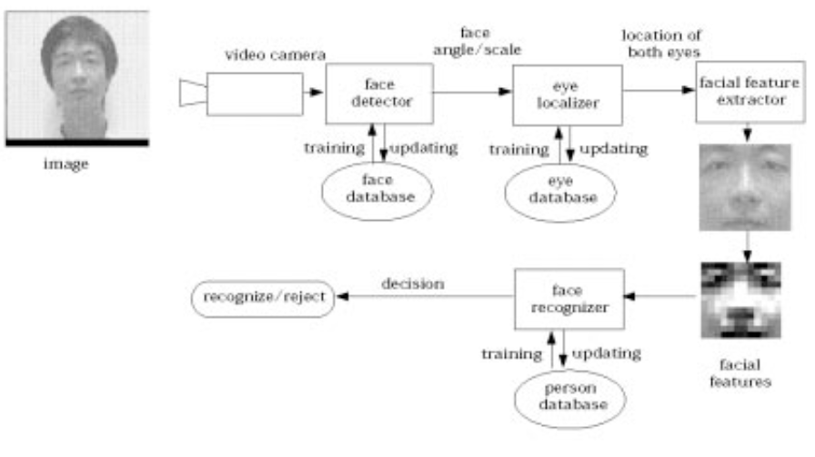

Data Flow Diagram

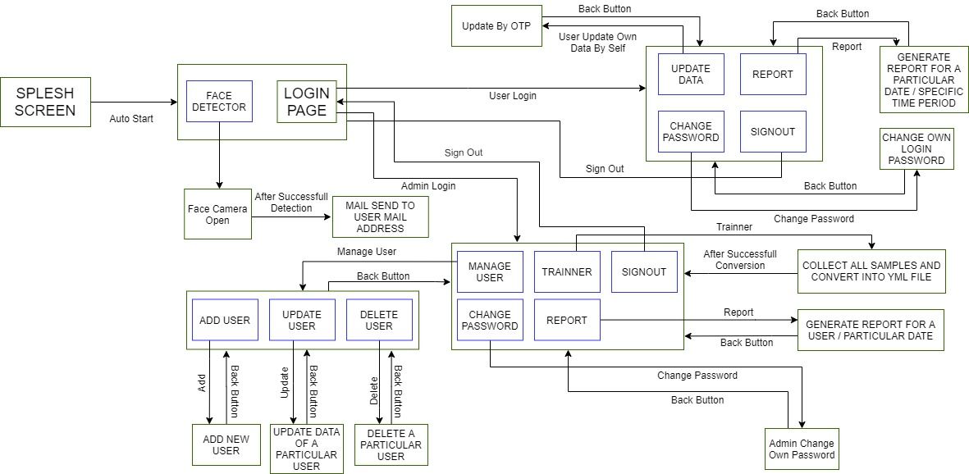

Use Case Diagram

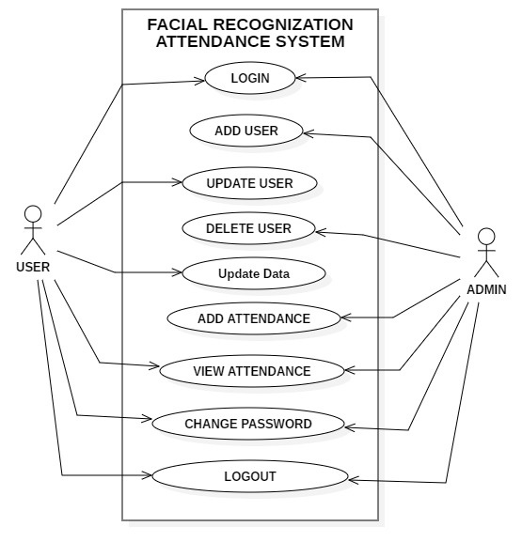

Database Overview

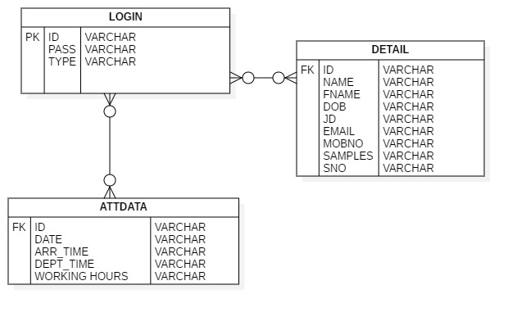

TOOL AND TECHNIQUE USED:

* Pycharm (usedfor development in Python)
* Adobe XD (Designing interfaces)
* SQLite (Database)

Application Feature Overview:

.

* Face rocognization attendance system is a automatic attendance system.
* It detects multiple faces at a time.
* It provides a login system for every user to maintain and see own data.
* It maintains number of different images in local system.
* It saves their time and effort.
* It sends email to the candidate where arrival time, departure time, working hours are written.

Code Snapshots

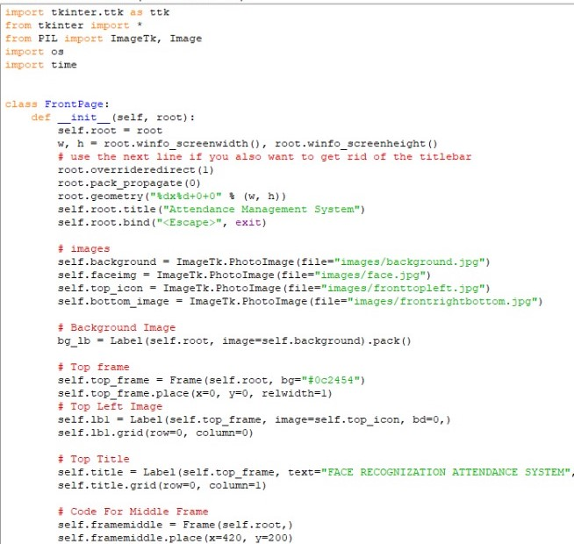

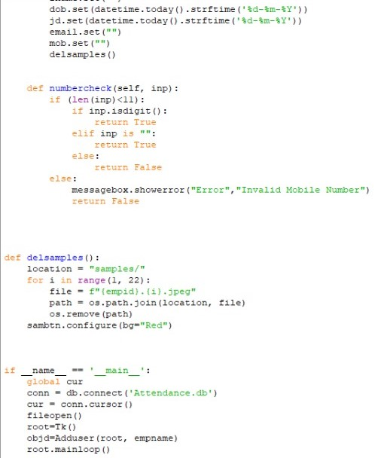

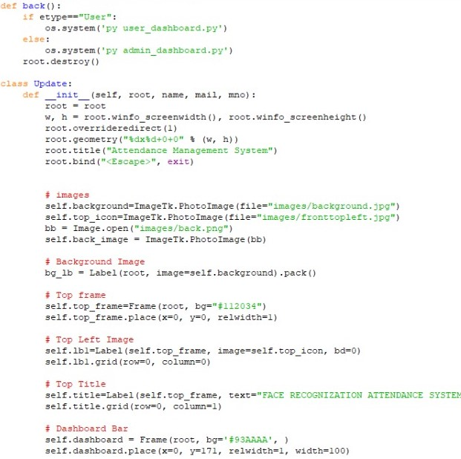



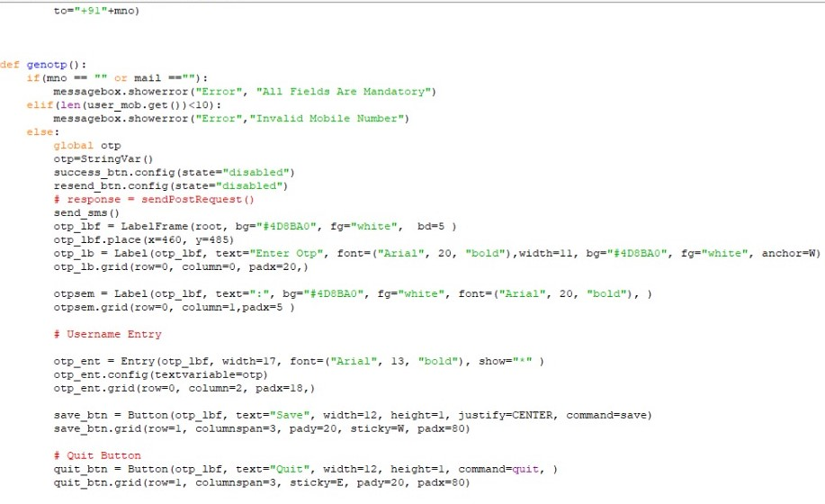

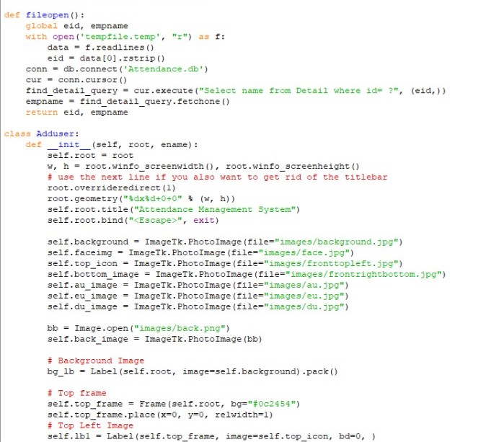

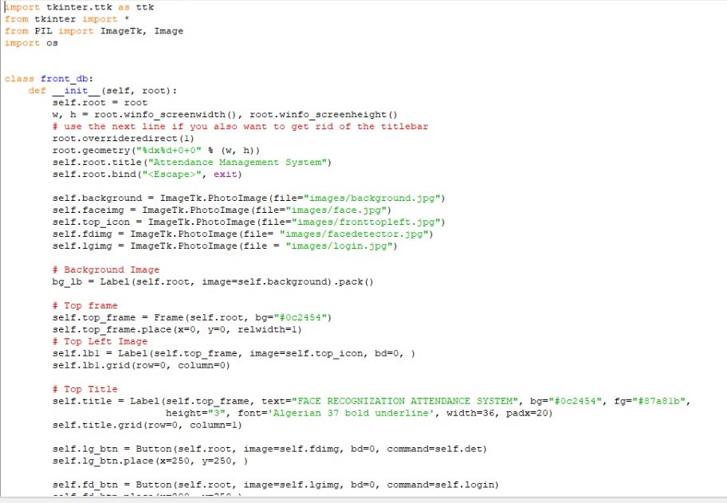

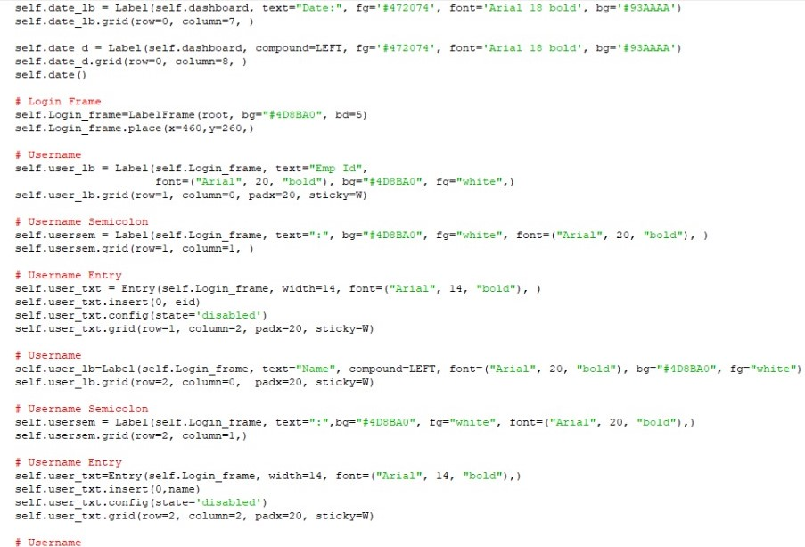

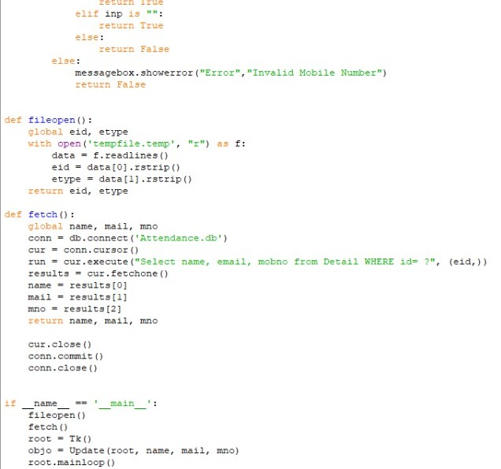

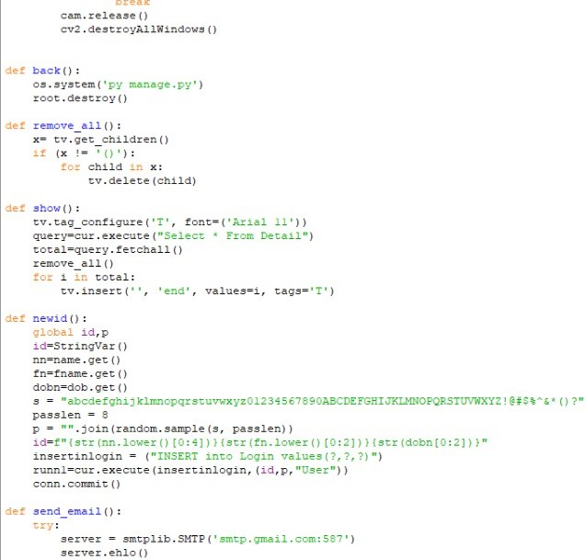

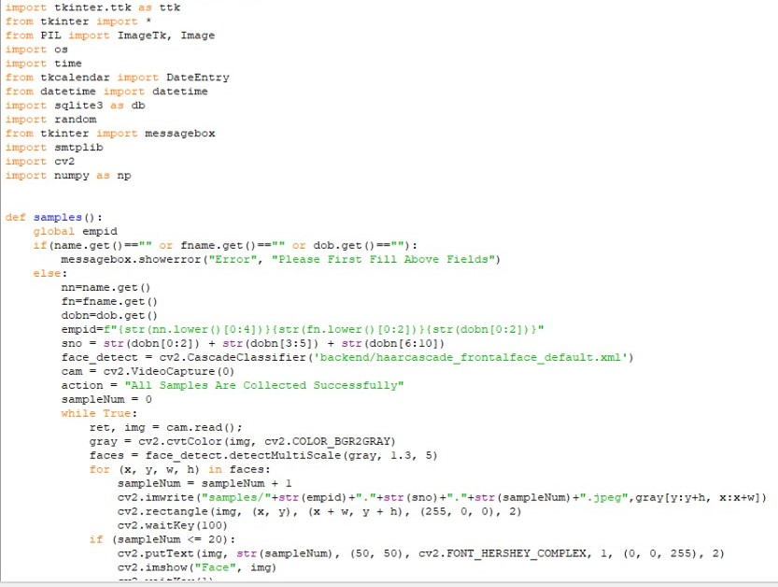

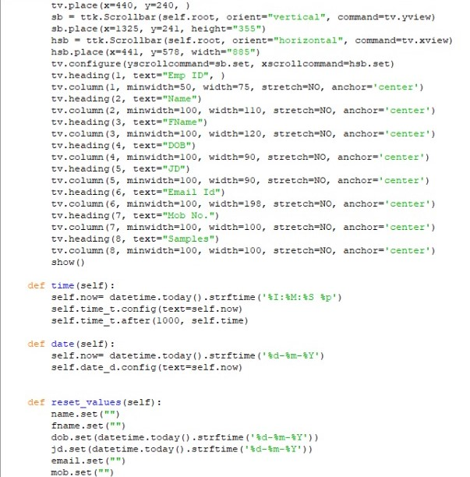

Output Screenshots:

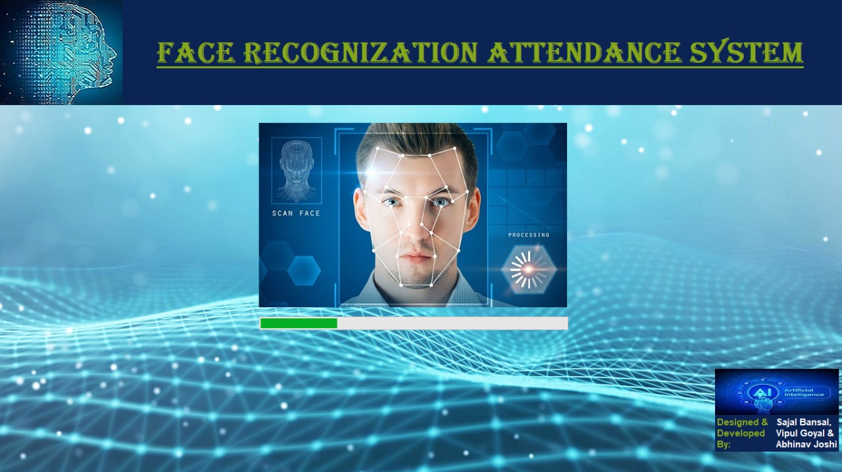

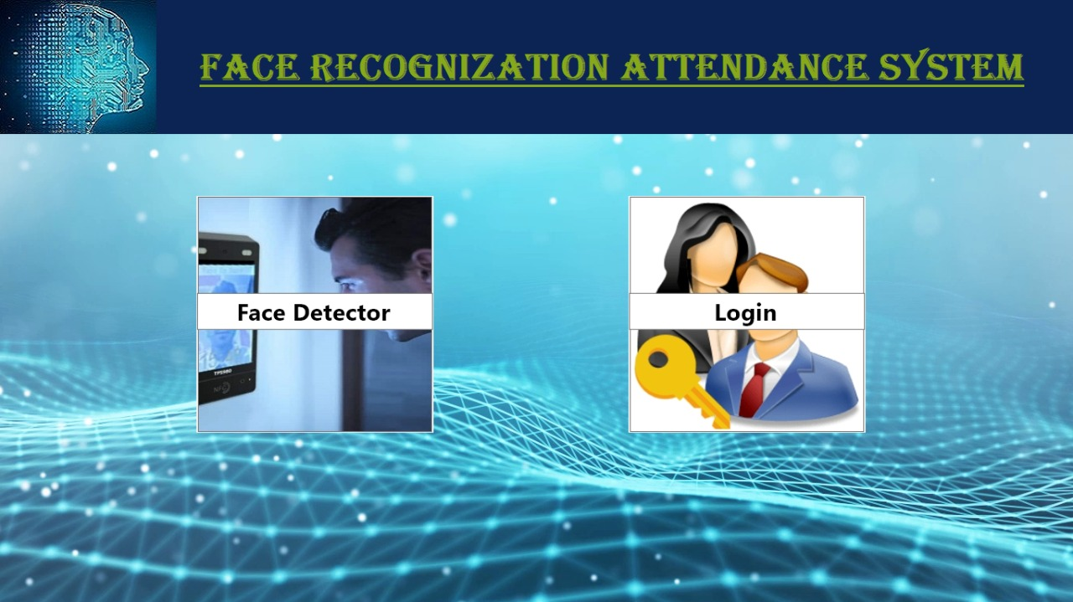

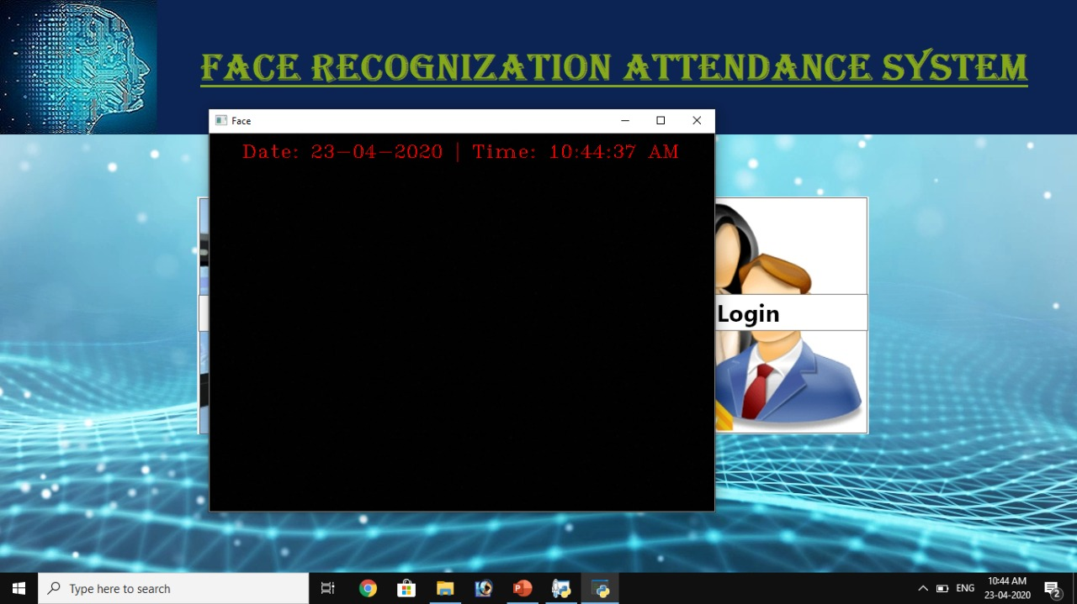

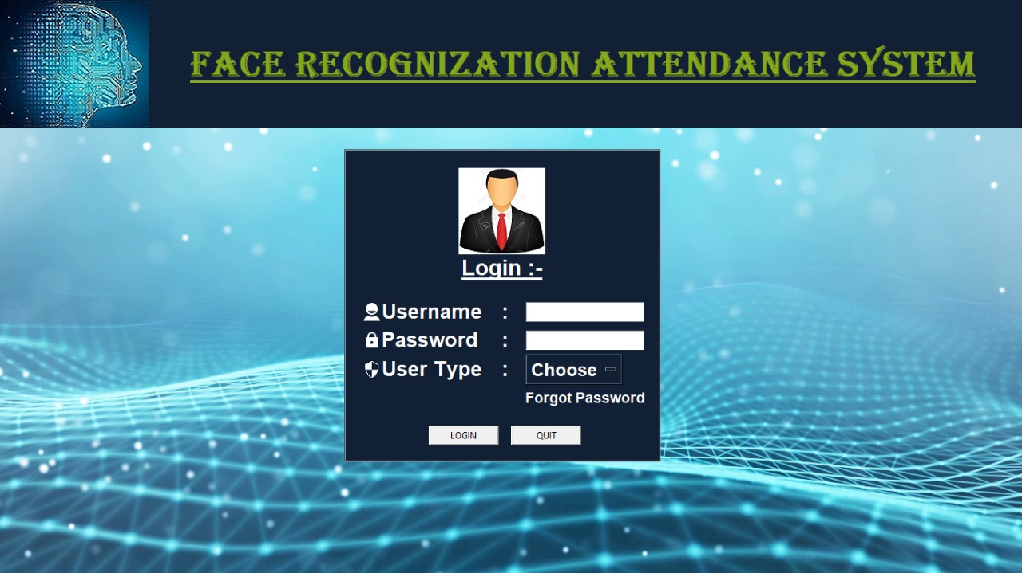

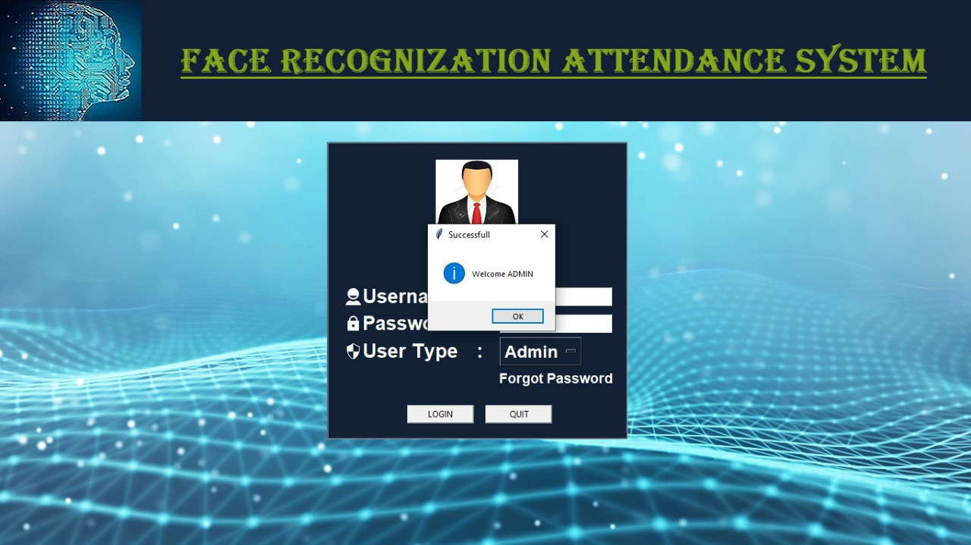

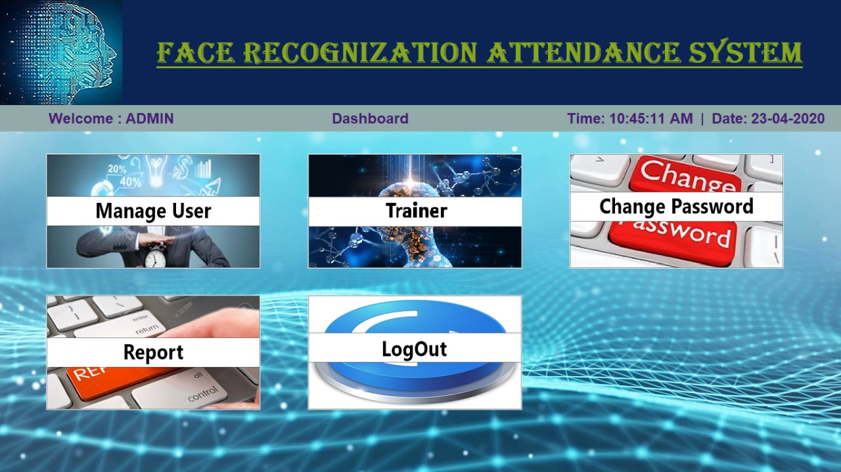

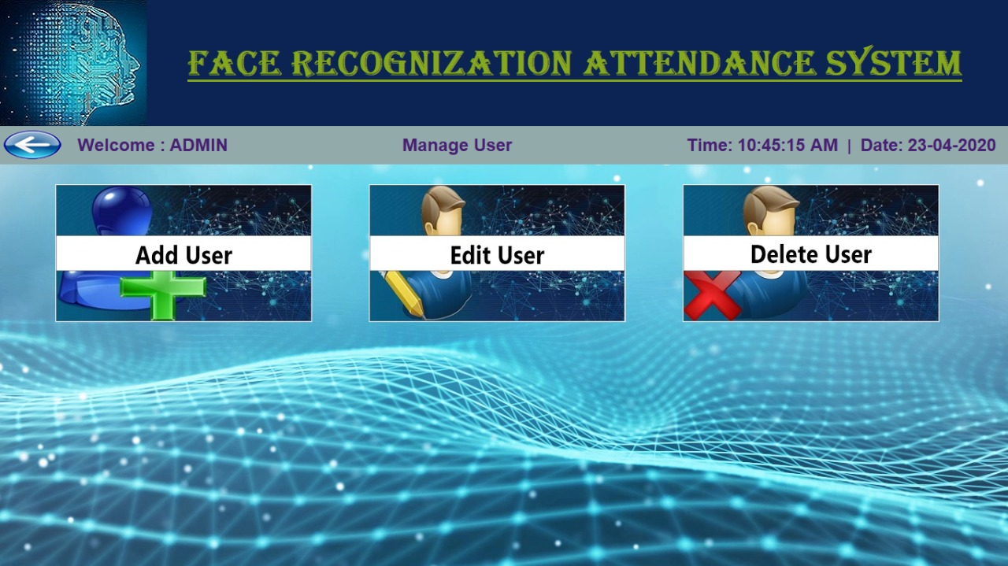

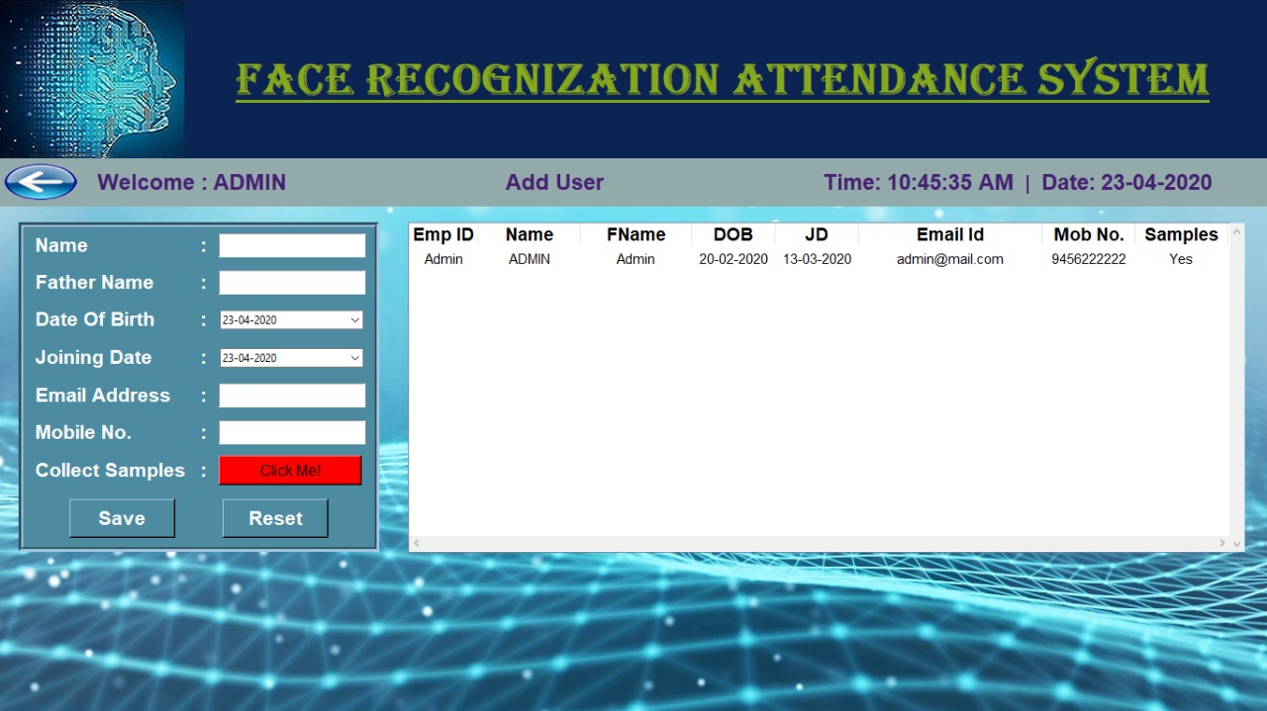

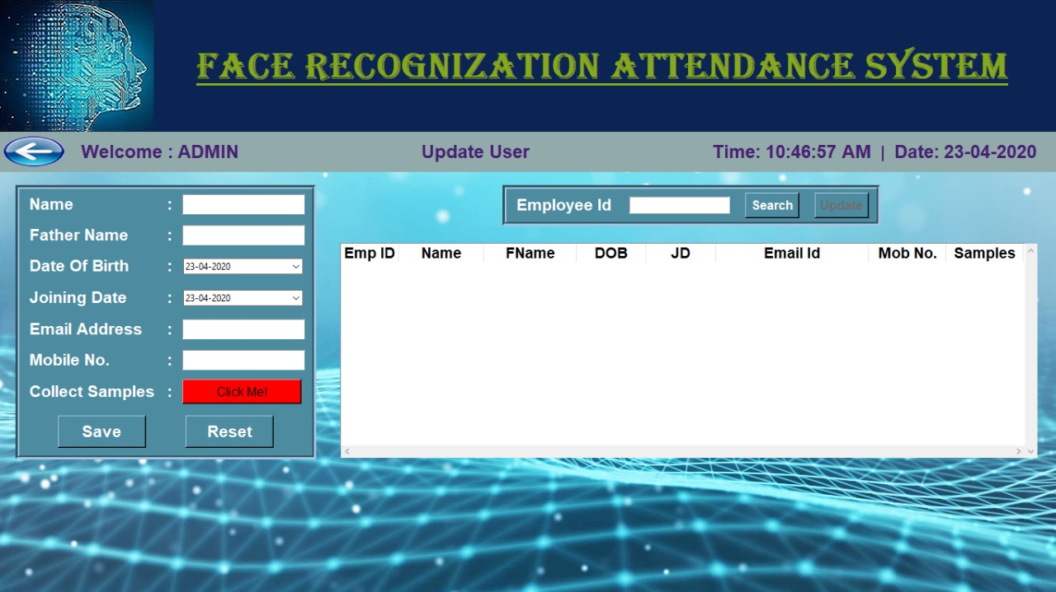

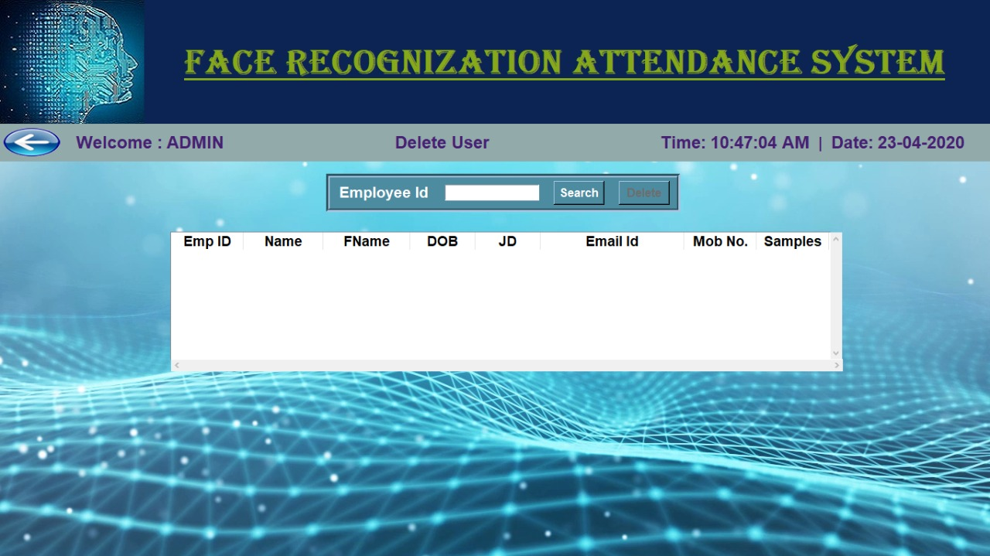

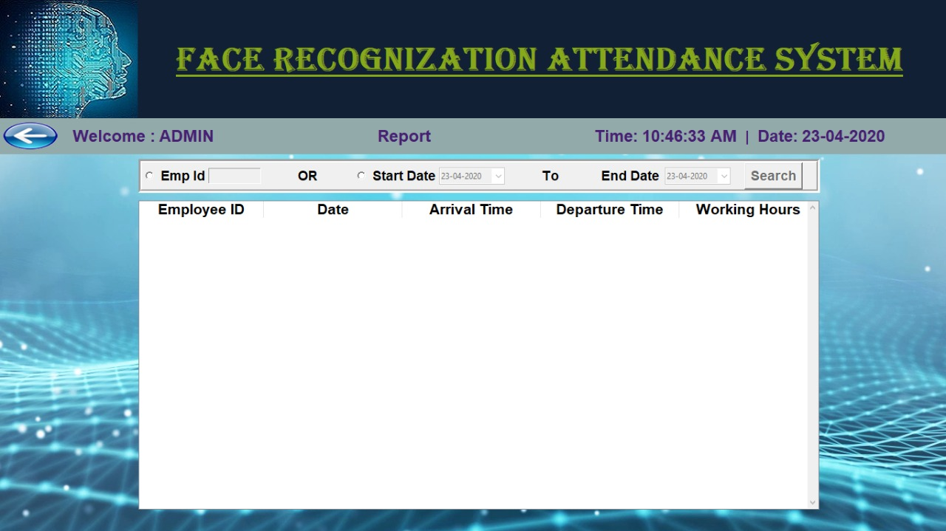

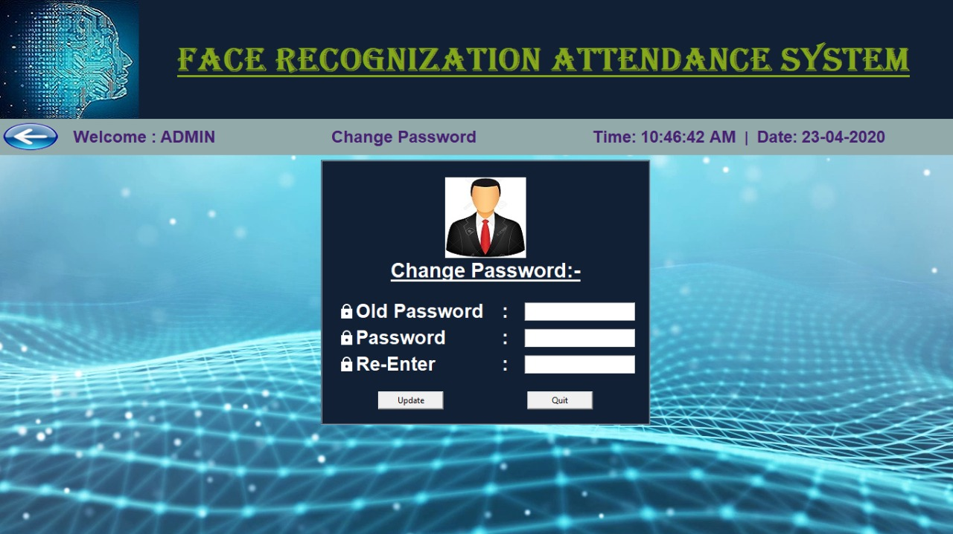

Limitations:

* Poor image quality limits facial recognition's effectiveness.
* Small images sizes make facial recognition more difficult.
* Data processing and storage can limit facial recognition tech.
* Different face angles can throw off facial recognition’s reliability.
* Expensive.
* Difficult with blog data processing and storing.
* Fooled by identical twins.

Future Enhancement:

* Make auto adjustable interface for every system supported.
* Try to improve complexity of algorithms and try to develop a new algorithms.
* Implement in biometrics identification using a fingerprint or face image or recorded voice and others.
* Provide attendance report by messages.
* Try to take attendance using voice recorded automatically.

Conclusion:

* The project exposed us to the latest technology in the universities and offices. This project successfully demonstrated as biometric method that will be of great use to the student and the office employees.
* For implementations where the biometric system must verify and identify users reliably over time, facial scan can be a difficult task, but not impossible.
* We acknowledge with great thanks to our supervisor “Er. Lalit Mohan Gupta” for his most valuable suggestion and co-operation.

Reference:

* <https://www.google.com/search?q=face+recognition&oq=facerec&aqs=chrome.2.69i57j0l7.4796j0j7&sourceid=chrome&ie=UTF-8>
* <https://stackoverflow.com/questions/tagged/opencv>
* <https://docs.opencv.org/2.4/modules/contrib/doc/facerec/facerec_tutorial.html>
* <https://www.youtube.com/watch?v=h21wMKGs0qs>

Thank You